Assessing the Quality of Greenspaces in Edinburgh Using Vegetation, Connectivity, and Existing Flood Defence Infrastructure as Indicators of Flood Risk

Capital Greenspace Project 2024

Group 6 – Flood Management



B235562, B270531, B269482, B263983, B263126, B271000

# Acknowledgements

During the design and implementation of this project, our group has received support and assistance from many people, to whom we would like to express our sincere gratitude.

Firstly, we would like to express our sincere gratitude to our professors and leaders - Dr. Neil Stuart, Dr. Bruce Gittings, and Dr. Zhiqiang Feng - for their dedication to the planning and guidance of this project, and for providing direction and inspiration for our research.

Secondly, we would like to thank the other professors and educators who assisted us in this project – Dr. Chris Hill, Dr. Owen Macdonald, etc. We thank them for their professional knowledge and teaching, and for providing us with ideas, techniques, and practices to support our project.

Then, thanks to the classmates of GIS and EO for their help and valuable suggestions during the project. It is your support and co-operation that enabled us to improve our project.

In addition, we would like to give special thanks to the UK Government and the Scottish Government for providing data support. This detailed and critical information has provided a solid foundation for this study.

Finally, we would like to pay tribute to all the experts, scholars and practitioners working in the field of flood management and urban greenspaces. Thank you for your selfless dedication and great contribution to flood management and environmental protection.

# Abstract

The aim of this study is to assess the quality of Edinburgh's greenspaces through their relationship to environmental deprivation and flood management. Data sources include Scottish Index of Multiple Deprivation, the British Geological Survey, and the Ordnance Survey. The study selected 30 greenspaces in Edinburgh with the highest and lowest levels of deprivation and flood risk areas, in order to assess their quality. Six metrics are evaluated to determine greenspace quality: land cover, flood infrastructure, presence of water, slope, elevation, and connectivity. Then investigate the correlation between total score and SIMD and flood risk. In addition, the study introduces 4 different weightings allocation methods, recalculates the total score by adjusting the weightings of 6 variables, and further conducts correlation analysis.

The results show that the correlation between the initial score and the deprivation coefficient is positive and the correlation between the initial score and the flood risk coefficient is negative, but the result is not significant (p>0.05). However, the correlation still suggests that the improvement of greenspace quality has the possibility of inhibiting the degree of deprivation and flood risk. The future research direction may need to make the following improvements: increase the sample size of greenspace in Edinburgh and select cities with less greenspace in the same region for additional analysis (Glasgow, Dundee, etc.), and compare them with Edinburgh.

# Table of Contents, Tables and Figures

Contents

Acknowledgements 1

Abstract 1

Table of Contents, Tables and Figures 3

1. Introduction 5

2. Literature Review 5

3. Methodology 6

3.1 Data sources 6

3.2 Site Selection and Map Digitisation 6

3.3 Scoring system and variable setting 8

3.4 Correlation Analysis 10

3.5 Database Design and Queries 12

4. Results 12

5. Discussion 13

6. Conclusion 14

7. References 15

Appendix A: Team Contributions 18

Appendix B: Oracle E-R Model 20

Appendix C: SQL Database Design 21

Appendix D: Oracle Table Creation 22

Appendix E: Oracle Control Files for Data Loading 23

Appendix F: Oracle Queries and Output Format 25

Appendix G: Literature Review 27

Appendix H: Risk Assessment 29

Total Word Count: 1939

Tables

Table 1: Greenspace quality metrics scoring per feature 8

Table 2: Output of initial greenspace scoring with no weightings 9

Table 3: Scoring scenarios for weighting and normalisation 10

Table 4: Output of greenspace scoring with normalisation and weightings. 10

Table 5: Final scoring of selected greenspaces 13

Figures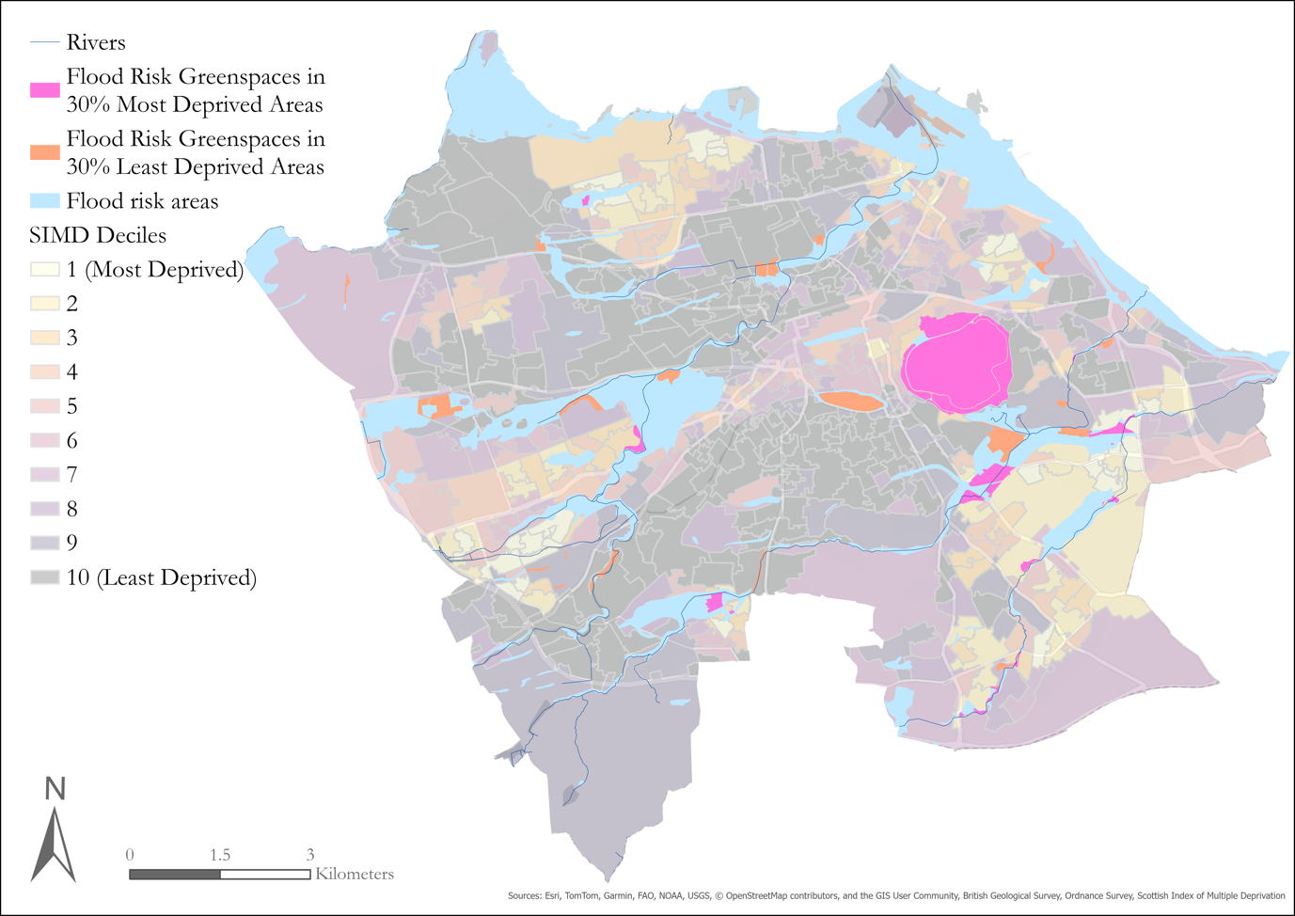

Figure 1: Map of greenspace site selection in the City of Edinburgh 7

Figure 2: Polygons of Inch Park as an example of greenspace digitisation. 8

1. Introduction

In collaboration with the Central Scotland Green Network (CSGN) and the City of Edinburgh Council, this study aims to comprehensively assess the value of greenspaces within Edinburgh city limits. Environmental deprivation in relation to greenspace refers to the unequal distribution of access to recreational areas or green infrastructure and their benefits that disproportionately affect marginalised communities (Pearce *et al.*, 2011). Deprivation can manifest in many ways, such as poor air quality and pollution, higher flood risk, limited opportunities for outdoor access that contributes to health disparities among various socio-economic levels (Hazell, 2020; Pearce *et al.*, 2011). By identifying and characterising greenspaces based on their connectivity and infiltration capacity, this report aims to address environmental quality and accessibility in terms of flood risk with the following research questions:

* What is the quality of greenspaces using vegetation, connectivity, and existing flood defence infrastructure as indicators of flood management?
* Is there a difference in how effectively greenspaces mitigate flood events in areas with high deprivation compared to areas with low deprivation?

The role of vegetation cover in flood management and risk reduction is critical (Milazzo *et al.*, 2023). Vegetation cover in greenspaces absorbs rainfall and reduces surface runoff, a vital element in preventing urban flooding (Milazzo *et al*., 2023). Further, connectivity of greenspace has the potential to create integrated drainage systems that contribute to mitigating flood events (Staccione *et al*., 2024). Such analysis garners insights into the quality and extent of greenspaces, the populations they serve, and the areas in most need of intervention. Ultimately, this report seeks to inform funding and policy decisions that increase equity and environmental sustainability throughout Edinburgh's diverse communities.

1. Literature Review

The relationship between environmental deprivation and natural flood management is a complex and multi-faceted issue. Much research has been done into environmental deprivation, which is typically defined as the lack of access to physical environmental conditions that can positively contribute to health and well-being, or high-quality greenspaces (Centre for Research on Environment, Society and Health, 2024). The benefits of greenspaces for flood management are only beginning to be acknowledged, but their accurate assessment is crucial towards understanding their role in this area (Schuch *et al.*, 2017). Studies show that enhancing green infrastructure makes a significant contribution to urban flood management by increasing vegetation cover and groundwater storage (Zimmermann *et al*., 2016). Vegetation significantly mitigates flood risks by enhancing water absorption and reducing surface runoff. Trees improve soil structure through their root systems, promoting infiltration and minimising runoff, while grass areas slow down water flow, allowing for greater absorption (Archer *et al.*, 2015; Regüés *et al.*, 2017). Greenspaces have previously been evaluated to determine their overall quality via the use of aerial imagery (Wang *et al*., 2021; Baka and Mabon, 2022). Though these studies quantified greenspaces for their benefits around mental health, it suggests that this methodology is potentially viable in other contexts. With the use of appropriate metrics, greenspaces should also be evaluated for their benefits in flood management in the same manner. For a more in-depth literature review, please see Appendix G.

1. Methodology

3.1 Data sources

Data from the Scottish Index of Multiple Deprivation (SIMD), the British Geological Survey (BGS), and the Ordnance Survey (OS) were used to select greenspaces at highest flood risk in areas of the 30% highest and lowest environmental deprivation. Data from SIMD is from 2020 and shows the multiple deprivation index in deciles. BGS data from 2010 shows the geological indicators of flooding based on their risk of flooding from fluvial or coastal water, each divided into two categories of lower or higher flooding potential. A map of greenspaces in Edinburgh was used from OS. This data is updated every six months and was downloaded in October 2024.

3.2 Site Selection and Map Digitisation

Using ArcGIS Pro, the greenspace data was clipped to show only those lying within the identified flood risk areas. There is inherently limited overlap between SIMD areas and greenspaces, as SIMD is focused specifically on where people live. The clipped greenspaces were divided into SIMD areas based on intersections of the 30% most deprived and 30% least deprived SIMD zones. The deprivation areas were distinguished at this point in the study to ensure equal inclusion of sites across areas for later analysis. Using the overlap of flood risk areas, a total of 30 greenspaces were selected for this study (Figure 1). The sites chosen were the largest 15 greenspaces in areas of highest and lowest deprivation. Greenspace area ranged from 1,508 to 2,813,517 m2 with a median of 141,286 m2.

 Figure 1: Map of greenspace site selection in the City of Edinburgh using flood risk areas and shown according to intersection with the nearest SIMD area.

The selected greenspaces were digitised based on land cover. Five of these sites were also validated in person to confirm that the satellite imagery was representative, and features could be accurately determined. Digitisation was done using QGIS with Google satellite imagery as a base layer and DTM and DSM layers were created from open-source LiDAR data. Using individual polygons, outlines were drawn around each greenspace, areas of trees, grass, impermeable surfaces, and flood infrastructure (Figure 2). These polygons were used to calculate area, slope, and elevation for each feature of the selected greenspaces. This data was later cleaned and analysed in Microsoft Excel.

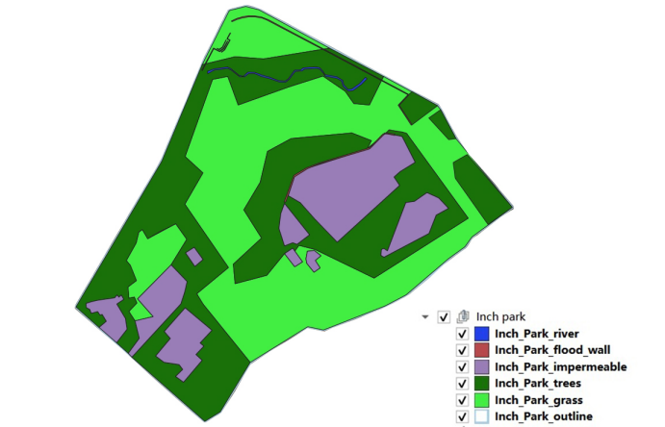

Figure 2: Polygons of Inch Park as an example of greenspace digitisation.

3.3 Scoring system and variable setting

A simple scoring system was designed to assess the quality of greenspaces as objectively as possible. Attributes considered included the presence of flood control infrastructure, the presence of canalisation, the presence of water bodies, area, land cover, slope, elevation and connectivity, which were set as independent variables. The sum of the above attributes is used as the total score and is set as the core argument. SIMD scores and flood risk potential scores are derived from existing data and set as dependent variables (Table 1).

Table 1: Greenspace quality metrics scoring per feature.

|  |  |  |  |
| --- | --- | --- | --- |
| Attribute | Scoring rules | Notes | Variable type |
| Land cover [1] | On a scale of -1 to +1 based on percentage.  Upper 10% of component score weighted based on park area | Represents the favourable impact of trees on flood risk mitigation, less the adverse impact of impermeable surfaces, scaled to reflect park area | Independent variable |
| Flood wall infrastructure | Present +1  Absent and not applicable 0  Absent -1 | Flood wall, reservoir, dam, gate | Independent variable |
| Presence of water | Present +1  Absent 0 | Benefit of existing water in syphoning/collecting rainfall | Independent variable |
| Canalisation | Present -1  Absent and not applicable 0  Absent +1 | Canalisation is a potential cause of flood, so it is set as a deduction | Independent variable |
| Mean slope [2] | Relative slope across parks scaled between 1 and -1 | More significant slope is an adverse score due to run-off potential | Independent variable |
| Mean elevation 2 | Relative elevation across parks scaled between 1 and -1 | More significant elevation is also an adverse score due to run-off potential | Independent variable |
| Connectivity | Present scaled between 0 and 1 depending on number of connections  Absent -1 | No park connections scored a 0 | Independent variable |
| Total score | Sum | Sum of all the scores of above attributes | Core independent variable |
| SIMD score | Continuous index | Deprivation index derived from SIMD | Dependent variable |
| Flood risk potential score | Continuous index from 0% to 100% | Higher flood potential from rivers: the first areas to experience the effects of inland flooding in a river catchment (From BGS). | Dependent variable |

3.4 Correlation Analysis

Initial scoring of the 30 greenspaces included no weightings to reflect the relative value of each component of the greenspace quality score (Table 2). The correlation between each component, and the SIMD and flood risk indicators, suggests which variables are driving our scoring. The land cover score is strongly inversely correlated to flood risk potential, reinforcing our approach on scoring this variable. Land cover is also positively correlated to SIMD (23%), which supports our hypothesis that better quality parks are in less deprived areas.

Table 2: Output of initial greenspace scoring with no weightings.

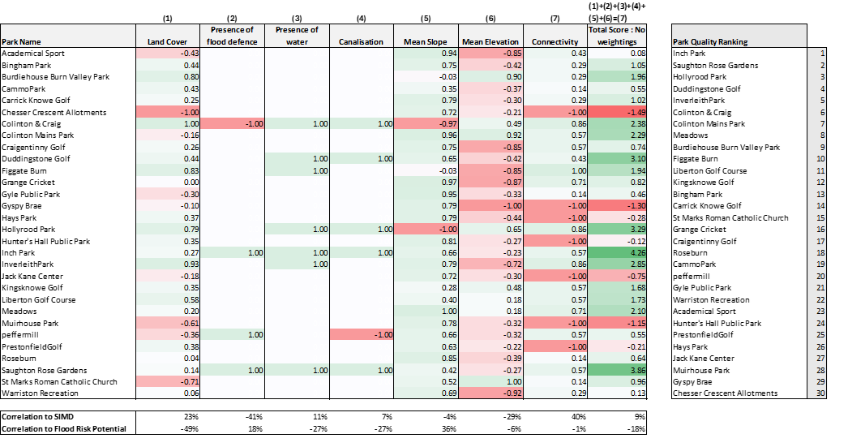

The following scenarios were considered to facilitate judgement around the appropriate weighting for each component of the greenspace quality score (Table 3):

* Review of correlation to SIMD and use of regression coefficients as proxy weightings;
* Review of correlation to flood risk and use of regression coefficients as proxy weightings;
* Normalisation of variables such that the sum of all columns (1-7 in Table 2) is equally weighted. This is not true in the initial scoring due to skew of the variables around zero;
* Subjectively selected weightings based on a previous study (Chen, Wang and Wu, 2024) and analysis of the variable correlation to SIMD and flood risk score.

Table 3: Scoring scenarios used for weighting and normalisation of greenspace features.

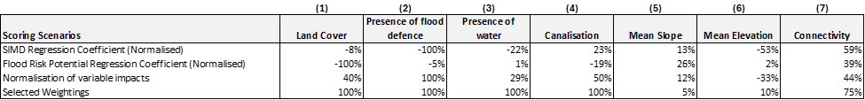

The unweighted initial scoring shows a 9% correlation to SIMD and a -18% correlation to flood risk potential (inverse of effectiveness for flood mitigation – so a negative correlation to flood risk is good in this case). They are not 100% correlated because the coefficients are used as proxies and are not fit directly to the data. Normalising the variables so they are scaled has an increase for SIMD but a decrease to flood risk, compared to the initial scoring (Table 4). Using weightings based on Chen, Wang and Wu (2024) and on field work carried out by the team, weightings were selected for the coefficients which balance the correlation between SIMD and flood risk potential (15% and -28%).

*Table 4: Output of greenspace scoring with normalisation and weightings.*

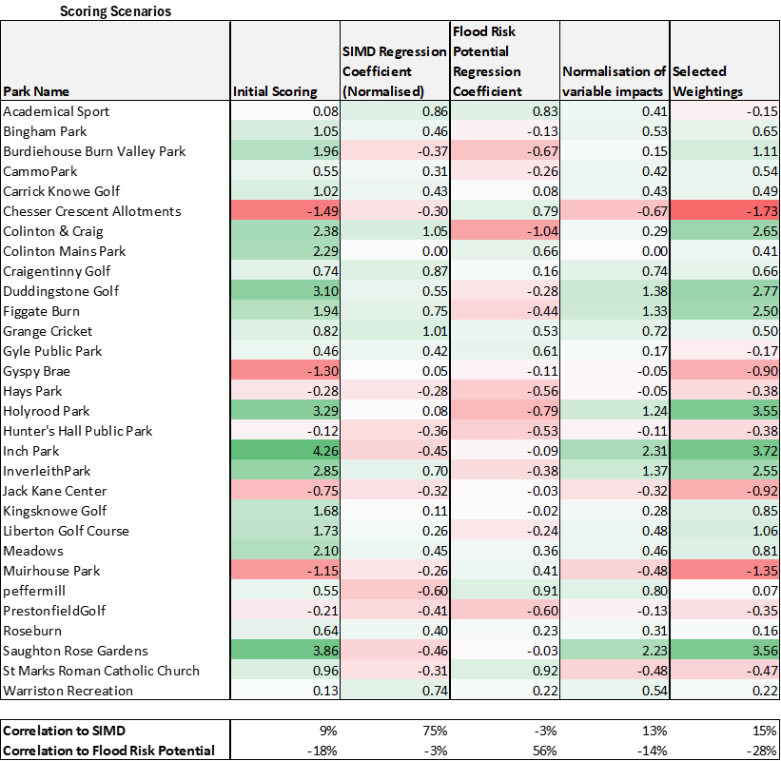

3.5 Database Design and Queries

All original data was stored in an Oracle database in four tables based on the attribute categories: Basic_Info, Flood_Info, Geography_Info, and Scoring_Info. SQL statements for table creation and the corresponding ER diagram are shown in Appendix B, C and D. The data loading process involves initially converting the data into a .dat format, followed by the creation of a control file (Appendix E). Subsequently, the sqlldr command is used to load the data. Finally, queries were designed and executed to extract specific information (Appendix F):

* Greenspaces with flood infrastructure;
* Greenspaces with more than 30% trees and flood infrastructure;
* Greenspaces with a ranking of deprivation.

1. Results

By sequentially introducing the four weighting scenarios in Table 3 and re-ranking the total score, the following results were obtained. The colour of the total score is determined by the Selected Weightings column of Table 5, with scores ranked by colour from highest to lowest in the following order: green, blue, white, yellow, and red. Overall, green and blue labelled greenspaces tend to be ranked higher in the normalised SIMD rankings, suggesting lower levels of environmental deprivation; at the same time, these greenspaces seem to have lower scores for Flood Risk Potential. Comparatively, greenspaces labelled in yellow and orange scored poorly, with the majority being lower in the normalised SIMD rankings and scoring higher for Flood Risk Potential.

Table 5: Final scoring of selected greenspaces based on described scenarios.

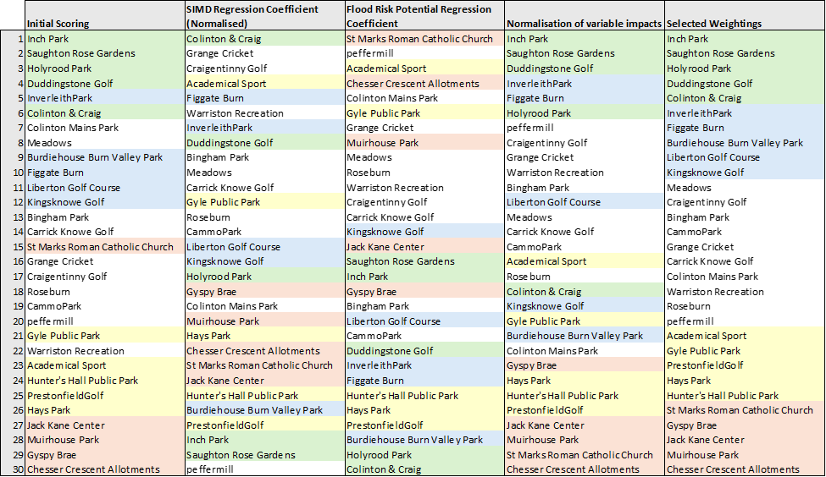

1. Discussion

The analyses conducted in this study yield meaningful correlations. The initial score relationship between greenspace and SIMD was 9%, and the relationship between greenspace and flood risk potential was -18%. After weighting, these scores improved to 15% and -28% respectively. However, the model reveals weak explanatory power for the SIMD as it only explains 7.09% of the variance in the effectiveness of greenspace. Furthermore, the p-value of 0.155 suggests that the results are not statistically significant, implying a 15.5% probability that the observed associations are due to random chance rather than a true relationship. This shows the complexity of the factors involved in flood management and emphasises the need for more thorough study.

The results suggest that greenspaces with higher vegetation cover and better connectivity tend to perform better in reducing flood risks. The linear regression analysis reveals a negative coefficient of -49% between land cover and flood risk potential, which is the only significant variable, indicating that greater vegetation cover leads to lower flood risk.

It is important to note that the analyses found minimal differences in flood risk mitigation between areas with the highest and lowest levels of deprivation. This could be explained by Edinburgh's profusion of greenspaces, which make up about 49% of the total area in the city (BBC, 2017). A more consistent degree of flood resistance across different socioeconomic strata is likely a result of this vast network of greenspaces. Additionally, the small sample size in this study limits the ability to detect more nuanced variations. Furthermore, Edinburgh is generally less deprived compared to other urban areas, which could account for the limited disparities observed.

Future research should expand the sample size in Edinburgh and conduct similar analyses in cities with less greenspace to further investigate our findings, for instance, Glasgow has about 32% greenspace and Dundee has approximately 41% (BBC, 2017; Dundee City Council, 2024). Looking at different cities in approximate regions can identify effective tactics that can be modified for Edinburgh and encourage cooperation amongst municipalities to tackle common issues. Moreover, collaborating with local communities to monitor and assess the performance of these greenspaces over time will be vital for informing policy decisions and promoting sustainable urban environments.

1. Conclusion

This study has brought attention to the vital role that greenspaces play in flood management, especially considering Edinburgh's environmental deprivation. Through an evaluation of 30 chosen greenspaces according to land cover, connectivity and current flood defence infrastructure, the results show that well-integrated greenspaces can mitigate flood risks. The study emphasises the importance of providing equal access to greenspaces because they are essential parts of urban flood defence systems in addition to offering recreational advantages.

1. References

Archer, N.A.L., Otten, W., Schmidt, S., Bengough, A.G., Shah, N., and Bonell, M. (2016). Rainfall Infiltration and Soil Hydrological Characteristics Below Ancient Forest, Planted Forest, and Grassland in a Temperate Northern Climate. *Ecohydrology*, 9(4), pp.585-600. doi: https://doi.org/10.1002/eco.1658.

Baka, A. and Mabon, L. (2022). Assessing Equality in Neighbourhood Availability of Quality Greenspace in Glasgow, Scotland, United Kingdom. *Landscape Research*, 45(5), pp.1-14. doi: https://doi.org/10.1080/01426397.2022.2051458.

BBC. (2017). *Edinburgh and Glasgow Top UK List of Green Space Cities*. BBC. Available at: https://www.bbc.co.uk/news/uk-scotland-38522414.

Carter, J.G., Handley, J., Butlin, T., and Gill, S. (2017). Adapting Cities to Climate Change – Exploring the Flood Risk Management Role of Green Infrastructure Landscapes. *Journal of Environmental Planning and Management*, 61(9), pp.1535-1552. doi: https://doi.org/10.1080/09640568.2017.1355777.

Centre for Research on Environment, Society and Health (2024). *Environmental Deprivation*. CRESH. Available at: https://www.cresh.org.uk.

Chen, J., Wang, S. and Wu, R. (2023). Optimization of the Integrated Green–Gray–Blue System to Deal with Urban Flood Under Multi-Objective Decision-making. *Water Science & Technology*, 89(2), pp.434–453. doi: https://doi.org/10.2166/wst.2023.411.

Contreras, C.P., and Bonilla, C.A. (2018). A Comprehensive Evaluation of Pedotransfer Functions for Predicting Soil Water Content in Environmental Modeling and Ecosystem Management. *Science of the Total Environment*, 644, pp.1580-1590. doi: <https://doi.org/10.1016/j.scitotenv.2018.07.063>.

Dundee City Council. (2024). *Water environment, open space, play, recreation and sport*. Dundee City Council. Available at: [https://www.dundeecity.gov.uk/sites/default/files/publications/water_environment_and_greenspace_accessible.pdf.](https://www.dundeecity.gov.uk/sites/default/files/publications/water_environment_and_greenspace_accessible.pdf#:~:text=The%20report%20details%20that%20Dundee%20City%20covers%206300,Adding%20private%20gardens%20increases%20this%20figure%20to%2062%25.)

Fung, T.K., Richards, D.R., Leong, R.A.T., Ghosh, S., Tan, C.W.J., Drillet, Z., Leong, K.L. and Edwards, P.J. (2021). Litter Decomposition and Infiltration Capacities in Soils of Different Tropical Urban Land Covers. *Urban Ecosystems*. doi: https://doi.org/10.1007/s11252-021-01126-2.

Hazell, E.C. (2020). Disaggregating Ecosystem Benefits: An Integrated Environmental-Deprivation Index. *Sustainability*, 12(18), pp.7589. doi: https://doi.org/10.3390/su12187589.

Houston, D., Werritty, A., Ball, T. and Black, A. (2020). Environmental Vulnerability and Resilience: Social Differentiation in Short‐ and Long‐term Flood Impacts. *Transactions of the Institute of British Geographers*, 46(1), pp.102–119. doi: https://doi.org/10.1111/tran.12408.

Kim, H., Lee, D.-K. and Sung, S. (2016). Effect of Urban Greenspaces and Flooded Area Type on Flooding Probability. *Sustainability*, 8(2), pp.134. doi: https://doi.org/10.3390/su8020134.

Milazzo, F., Francksen, R.M., Zavattaro, L., Abdalla, M., Hejduk, S., Enri, S.R., Pittarello, M., Price, P.N., Schils, R.L.M., Smith, P. and Vanwalleghem, T. (2023). The Role of Grassland for Erosion and Flood Mitigation in Europe: A Meta-analysis. *Agriculture, Ecosystems & Environment*, 348, pp.108443. doi: https://doi.org/10.1016/j.agee.2023.108443.

Pearce, J.R., Richardson, E.A., Mitchell, R.J. and Shortt, N.K. (2011). Environmental Justice and Health: A Study of Multiple Environmental Deprivation and Geographical Inequalities in Health in New Zealand. *Social Science & Medicine*, 73(3), pp.410–420. doi: https://doi.org/10.1016/j.socscimed.2011.05.039.

Regüés, D., Badía, D., Echeverría, M. T., Gispert, M., Lana-Renault, N., León, J., Nadal, M. E., Pardini, G., and Serrano-Muela, P. (2017). Analysing the Effect of Land Use and Vegetation Cover on Soil Infiltration in Three Contrasting Environments in Northeast Spain. *Cuadernos de Investigación Geográfica*, *43*(1), pp.141–169. doi: https://doi.org/10.18172/cig.3164.

Schuch, G., Serrao-Neumann, S., Morgan, E. and Low Choy, D. (2017). Water in the City: Green Open Spaces, Land Use Planning and Flood Management – An Australian Case Study. *Land Use Policy*, 63, pp.539–550. doi: https://doi.org/10.1016/j.landusepol.2017.01.042.

Staccione, A., Essenfelder, A.H., Bagli, S., and Mysiak, J. (2024). Connected Urban Greenspaces for Pluvial Flood Risk Reduction in the Metropolitan Area of Milan. *Sustainable Cities and Society*, pp.105288–105288. doi: https://doi.org/10.1016/j.scs.2024.105288.

Rawls, W.J., Brakensiek, D.L., and Saxton, K.E. (1982). Estimation of Soil Water Properties. *American Society of Agricultural Engineers*, 25 (5), pp.1316-1320. doi: https://doi.org/10.13031/2013.33720.

Wang, R. Feng, Z., Pearce, J., Liu, Y. and Dong, G. (2021). Are Greenspace Quantity and Quality Associated with Mental Health Through Different Mechanisms in Guangzhou, China: A Comparison Study Using Street View Data. *Environmental Pollution*, 290, pp.117976. doi: https://doi.org/10.1016/j.envpol.2021.117976.

Yang, J.-L. and Zhang, G.-L. (2011). Water Infiltration in Urban Soils and Its Effects on the Quantity and Quality of Runoff. *Journal of Soils and Sediments*, 11(5), pp.751–761. doi: https://doi.org/10.1007/s11368-011-0356-1.

Zemke, J.J., Enderling, M., Klein, A. and Skubski, M. (2019). The Influence of Soil Compaction on Runoff Formation. A Case Study Focusing on Skid Trails at Forested Andosol Sites. *Geosciences*, 9(5), pp.204. doi: https://doi.org/10.3390/geosciences9050204.

Zimmerman, E., Bracalenti, L., Piacentini, R., Inostroza, L. (2016). Urban Flood Risk Reduction by Increasing Green Areas for Adaptation to Climate Change. *Procedia Engineering*, 161, pp.2241-2246. doi: https://doi.org/10.1016/j.proeng.2016.08.822.

# Appendix A: Team Contributions

Team organisation was a board-based structure, with all members raising issues and delegating tasks and one chair keeping the group moving when needed during weekly progress meetings. Such a method allowed members to take on tasks according to their skill set while also allowing flexibility in the leadership structure. Members were proactive in asking for help when required or raising issues, instead of waiting until the next team meeting to do so, allowing the group to remain on track with tasks.

|  |  |
| --- | --- |
| Team Member | Contribution |
| B235562 | * Literature review sources * Risk Assessment * Fieldwork * Presentation design and writing * Presentation * Introduction * Report editor |
| B270531 | * Literature review sources * Literature review * Greenspace digitisation * Quantifying greenspaces * Discussion * Conclusion |
| B269482 | * Fieldwork * Mapping * Metrics design * Methodology * Results |
| B263983 | * Literature review sources * Literature review * Fieldwork * SQL E-R Model * Presentation * Report editor * Gantt chart reflection * Project Manager/chairperson |
| B263126 | * Fieldwork * Methodology design * Presentation slides * Presentation * Analysis * Results * Report contribution * Gantt chart |
| B271000 | * Fieldwork * Map digitisation * Quantifying greenspaces * Database development and queries * Methodology * Results * Abstract |

# Appendix B: Oracle E-R Model

Basic Info

Scoring Info

Geography Info

Flood Info

Has

Looks like

Contain

N

N

N

M

M

M

Key:

= Entity

= Relationship between entities

= Many-to-many relationship

N

M

# Appendix C: SQL Database Design

Three main constraints were applied to the creation of these tables. The first constraint is Primary Key. Each table has a Primary Key, which is used to identify unique rows within a table. Each table uses the Primary Key ‘Park ID.’ The tables for Flood Info, Geography Info, and Scoring Info additionally all contain a Foreign Key. The Foreign Key is used to reference or link tables together. These tables all use the same Foreign Key, which is ‘Park ID.’ Finally, the constraint Not Null was applied to each table. The Not Null constraint prevents any empty cells from appearing within the tables. Given the size of the data files that were being used for this project, it would have been difficult to check each cell individually to make sure that all attribute data was included; Not Null has done that work for us.

Key:

|  |  |
| --- | --- |
| Primary Key | Foreign Key |

Basic Info table

|  |  |  |  |  |  |  |
| --- | --- | --- | --- | --- | --- | --- |
| Park ID | Park Name | Total Area | Grass | Impermeable | Trees | Other |

Flood Info table

|  |  |  |  |  |  |  |  |
| --- | --- | --- | --- | --- | --- | --- | --- |
| Park ID | Presence of Flood Defences | Presence of Water | Canalisation | Higher Flood Potential | Lower Flood Potential | Unassessed potential | Trees and Impermeable |

Geography Info table

|  |  |  |  |  |  |  |
| --- | --- | --- | --- | --- | --- | --- |
| Park ID | Mean Slope | Mean Elevation | Min. Elevation | Max. Elevation | Elevation Range | Connectivity |

Scoring Info table

|  |  |  |
| --- | --- | --- |
| Park ID | Deprivation | Total Score |

# Appendix D: Oracle Table Creation

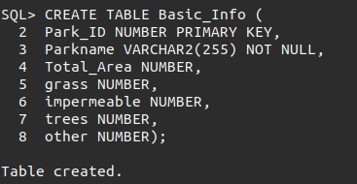

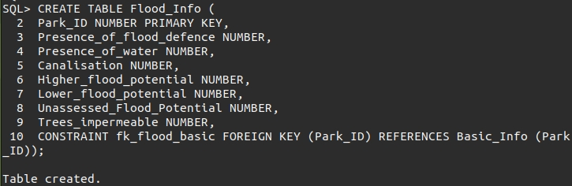

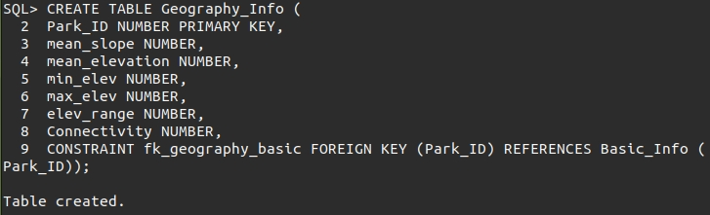

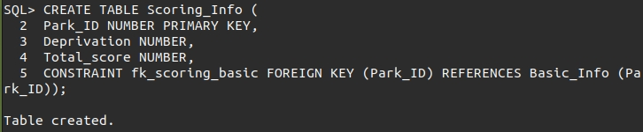

# Appendix E: Oracle Control Files for Data Loading

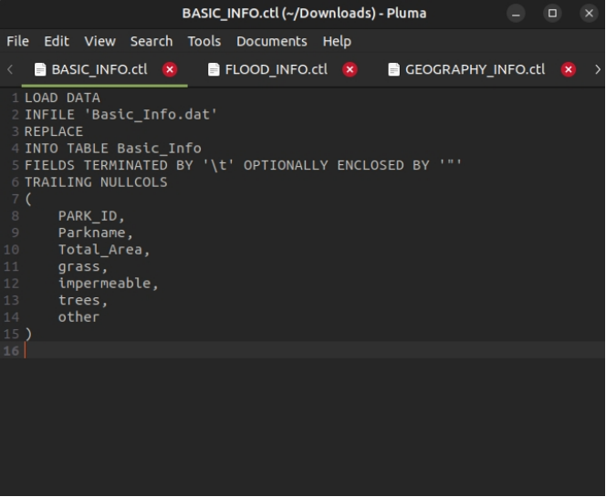

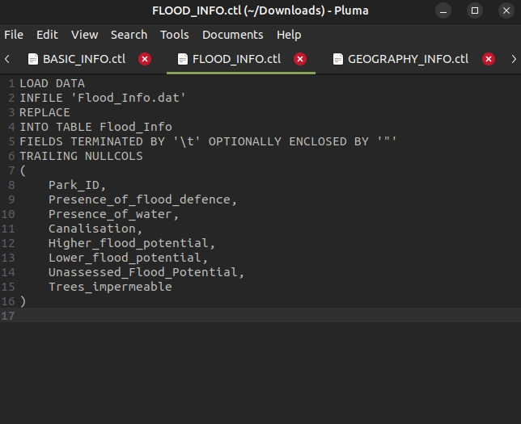

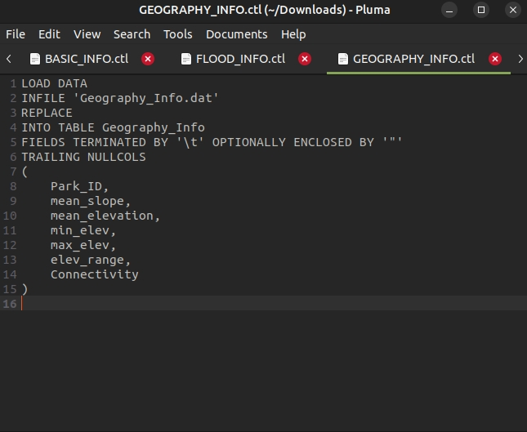

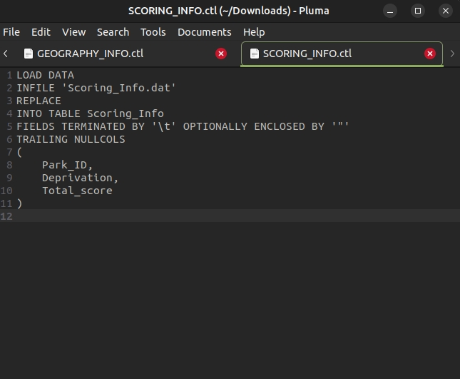

# Appendix F: Oracle Queries and Output Format

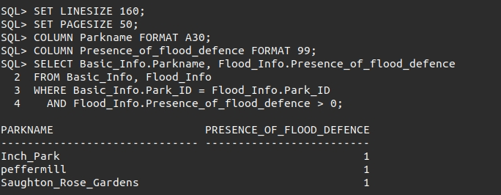

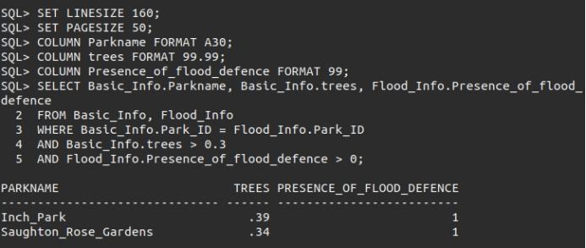

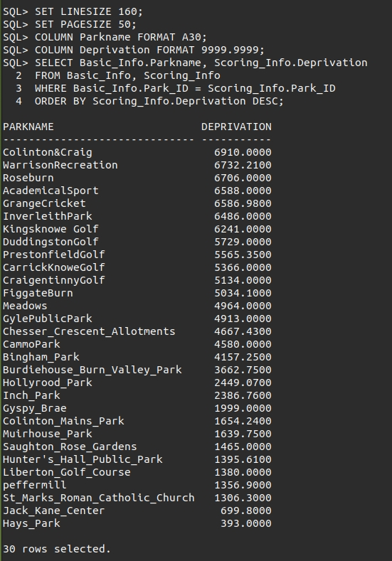

# Appendix G: Literature Review

Much research has been done around environmental deprivation, which is typically defined as the lack of access to physical environmental conditions that can positively contribute to health and well-being (Centre for Research on Environment, Society and Health, 2024). One way to think about access to “physical environmental conditions” would be in terms of access to high quality greenspaces. In general, environmental deprivation in the UK seems to increase as income deprivation also increases. This also seems to correlate with greater social disadvantage (Pearce *et al*., 2011). There is some room here for additional research, however. For example, the benefits of green open spaces for flood management are rarely acknowledged; however, their accurate assessment is crucial towards understanding the role they play in this area (Schuch *et al*., 2017). Studies do show that enhancing green infrastructure such as living roofs, parks, and flood plains, can make a significant contribution to urban flood management by increasing vegetation cover and groundwater storage capacities, ultimately reducing fluvial runoff. These benefits do increase when used in conjunction with traditional grey infrastructure such as storm drains and canalisation (Zimmermann *et al.*, 2016). Issues can also arise when greenspaces and infrastructure used as flood management cross into multiple political jurisdictions. It can also cause issues when a lack of green infrastructure upriver overwhelms flood management infrastructure downstream, especially when these are also in separate political jurisdictions (Carter *et al*., 2018). Additional research on this topic would be timely, given effects due to climate change, as well as research on green infrastructure in areas of deprivation. Interestingly, it also appears as though deprivation, specifically economic deprivation, has a much greater effect on long-term flood resilience, with those who are more economically deprived being less resilient to flooding in the long term (Houston *et al*., 2021).

It appears well researched and understood that soil compaction levels have a definitive effect on infiltration levels (which can contribute to flooding in post-fluvial events), with more compacted soil generally decreasing the infiltration level (Zemke *et al*., 2019; Yang and Zhang, 2011). Causes of soil compaction can include heavy pedestrian traffic, sports fields, compression by construction equipment, and more. The current literature does not appear to have studied whether soil is more likely to be compacted in areas of higher deprivation. Soil infiltration can also be affected by other factors such as pollution, with higher levels of pollution correlated with lower infiltration rates (Fung *et al*., 2022), as well as being affected by distinct types of vegetation. Water infiltration appears to be better under trees and old forests (Archer *et al.*, 2015), and then under scrubland and grasses, with variation in vegetation types being less of a determining factor than anticipated (Regues *et al*., 2017). Finally, soil infiltration appears to be affected by the type of soil, with sandy soils retaining the most water, and clay-based soils retaining the least water (Rawls, Brakensiek and Saxton, 1982; Contreras and Bonilla, 2018); however, much of this is outside the scope of this project.

Several studies have quantified greenspaces for their benefits through the use of satellite imagery and aerial photography, particularly in the area of mental health (Wang *et al*., 2021; Baka and Mabon, 2022). In both studies, greenspaces were assessed using multiple relevant metrics that are observable through satellite imagery and aerial photography, including presence of trees and degree of greenness. Though the purpose of this report is not in relation to mental health, it suggests that with the appropriate metrics, this methodology can be altered to fit other purposes. Ultimately, the use of aerial imagery can potentially be viable in accurately assessing greenspaces for their quality regarding flood management, though it does not appear to have been done before.

# Appendix H: Risk Assessment















1. Parks have been assigned a weighting between 0 and 1 based on their relative area (*i.e.* the largest park receives a weighting of 1 and the smallest a weighting of 0. The upper 10% of the land cover score is scaled based on this weighting: Land cover score = (% Area trees - % Area impermeable surfaces) * 90% + (Relative area score) * 10%
2. Mean slope and elevation have been normalized between -1 and 1 as follows:

   Normalised score (x) = (mean slope (x) – min(mean slope))/(max(mean slope) – min(mean slope))*2 -1

   Normalised score (x) = (mean elevation (x) – min(mean elevation))/(max(mean elevation) – min(mean elevation))*2 -1